Follow Greg’s case study through each question in the Transition Planning Process. This case study includes templates the team could use or adapt to capture student information and plans.

Transition Planning Cycle. The Transition Planning cycle unfolds as planning actions that take place in response to a set of questions:

Question One: Who is on the youth’s team?

Question Two: What do we know about the youth’s post school plans?

Question Three: What do we know about the youth?

Question Four: What else do we need to know? How will we get it?

Question Five: What do the data mean for the youth’s adult life outcomes?

Question Six: What steps will we put in place? How will we know they are effective?

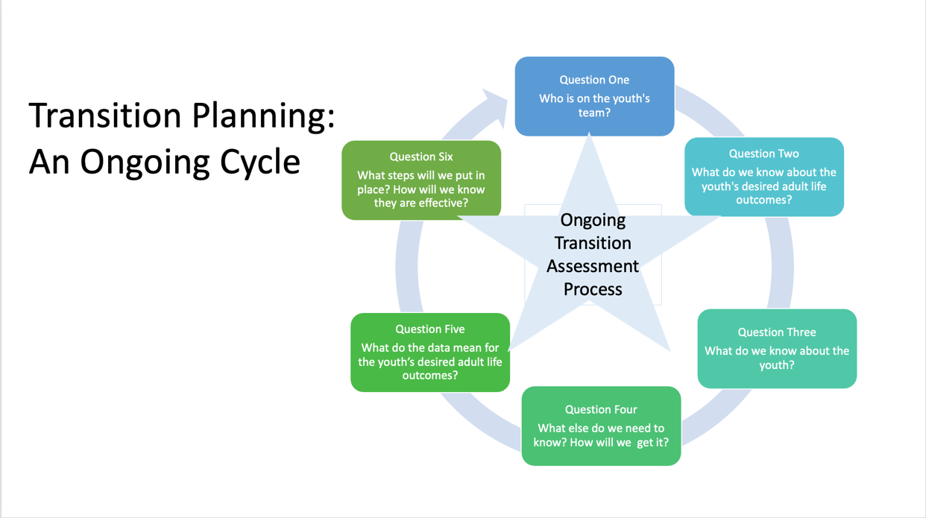

Gregory – Background Information
Gregory is a 15-year-old high school sophomore. He will turn 16 soon and it is time to formally begin transition planning. His teacher talks with Greg and his family about this at his annual IEP meeting. His mom attended a training where they discussed planning with a team that included other people and she is interested in this for Greg. His teacher contacts the local VR and the Disabilities Services offices for contact people to serve on the team. Greg also wants his brother and a neighborhood friend to be on the team. Greg has been receiving mental health services and his mom thinks his counselor would be a good team member. Everyone agrees to attend a meeting to begin transition planning.

Question One: Who is on the youth’s team?

Greg’s teacher contacted the people suggested for the team and arranged a date for them to meet. She used the Team Roster template to gather contact information to share with each team member.
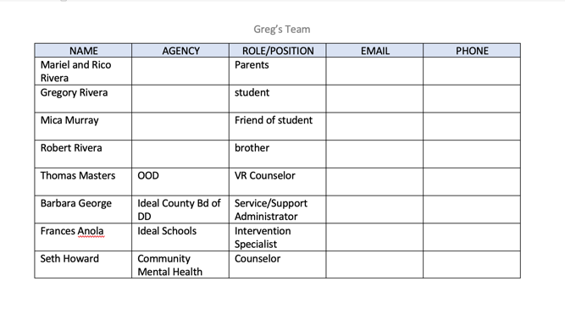
People on Greg’s planning team: Mariel and Rico Rivera, parents; Gregory Rivera, student; Mica Murray, Greg’s friend; Robert Rivera, brother; Thomas Master, VR Counselor; Barbara George, Ideal County Board of Developmental Disabilities; Frances Anola, Ideal School, Intervention Specialist; Seth Howard, Community Mental Health Counselor

Question Two: What do we know about the youth’s desired adult life outcomes?
All the people who committed to participate attended an initial transition planning meeting. They introduced themselves and agency representatives gave some background on what their agency does to support transition. Greg’s teacher was facilitating the meeting.
Greg has been persistent in talking about getting a job in retail. His older brother is a manager at a clothing store and Greg adores him. His family and teachers have real misgivings about retail being a good fit for Greg. He has some significant sensitivity to loud noises, certain lighting and lot a movement of people around him. These sensitivities may not be a good match with the sometimes-chaotic retail environment. When on overload, Greg is prone to self-harm.

Greg also talked about what he absolutely does not want to do in the future. No work outside, he dislikes bugs and birds flying around. No cleaning or food jobs, the smells are too strong and the lights too bright.

The team summarized their discussion using this Adult Life Goal Template.

The youth’s desired adult life outcomes can be summarized in a simple table (see image) organized as follows:

create four columns labeled from left to right, ‘Adult Life Goals’, ‘Ongoing Adult Learning Goal’, ‘Adult Competitive Integrated Employment Goal’, ‘Adult Living Community Membership Goal’;

create two rows; label one row ‘what I am interested in doing’ label the other ‘what I do not want to do’

This table can help to organize the information from the adult life goals discussions.

Adult Life Goals | Ongoing Adult Learning Goal | Adult Competitive Integrated Employment Goal | Adult Living / Community Membership Goal
What I Am Interested in Doing | Unsure | Work in a clothing store | Unsure
What I Do Not Want to Do | Unsure | No work outside, cleaning or food jobs  Greg dislikes bugs, birds, strong smells and bright lights | Unsure
The team has a little info about Greg’s future employment goals. They learned a lot about what he does not want to do for a work. Things to avoid will be helpful in planning and may also figure into future learning and living goals. The team used the rest of the meeting to learn more about Greg and build a PINS Profile.

Question Three: What do we know about the youth?
Everyone on the team has some personal experience with Greg, and all actively contributed from their perspective to the PINS Profile, especially Greg. He was very quiet at first, when he saw a whole bunch of group-ups at the meeting. The friend he suggested for the team came in a little late and sat next to Greg. After the introductions, when the conversation turned to Greg’s PINS, Greg realized this was different from other formal meetings and he began to add items to the emerging lists.

Greg’s mom noted that Greg said he liked doing things with his brother but she’s not really sure Greg has a true desire to work in retail. In fact, most of the things he does say indicate that a retail environment won’t be a good match for him.

The team was able to find a time to get back together in 2 weeks.

The team organized the information that surfaced during the discussion into this PINS Profile template.
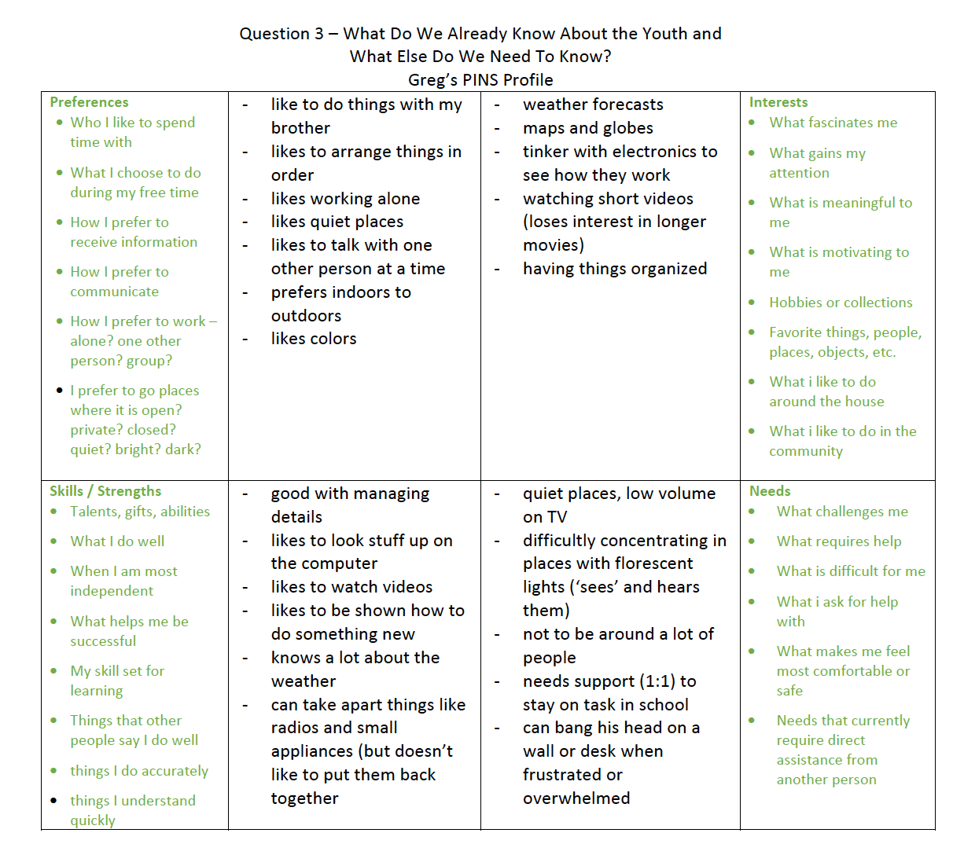
Greg’s Preferences are: likes to do things with his brother, likes to arrange things in order, likes working alone, likes quiet places, likes to talk with one other person at a time, prefers indoors to outdoors, likes colors

Greg’s Interests are: weather forecasts, maps and globes, tinker with electronics to see how they work, watching short videos (losing interest in longer movies), having things organized

Greg’s Needs are: quiet places, low volume on TV, difficulty concentrating in places with florescent lights (‘sees’ and hears them), not to be around a lot of people, needs support (1 on 1) to stay on task in school, can bang his head on wall or desk when frustrated or overwhelmed

Greg’s Strengths / Skills are: good with managing detail, likes to look stuff up on the computer, likes to watch videos, likes to be shown how to do something new, knows a lot about the weather, can take apart things like radios and small appliances but doesn’t like to put them back together.

Question Four: What else do we need to know? How will we get it?
Greg’s team reviewed his PINS profile to see where they had questions that could be explored with transition assessment data. They were most interested in probing Greg’s stated career interest of working in retail. Everyone (except Greg) thought the interest was based on how he enjoyed spending time with his brother. Other items in Greg’s profile indicate a disconnect with a career in retail such as sensory issues, crowds, and unpredictability. Greg does have some other interests – weather, maps, electronics and shows some skill with using small tools and working with small components.

Greg will need to gain some strategies and accommodations to manage his sensory needs more independently. Besides the anxiety Greg can experience on sensory overload, the team wants for him to avoid getting to the point of hurting himself.

Lots of other questions are possible. The team decided to start with these basic questions first.

The team organized their plan for transition assessment to make it easy to share with all members.
Greg’s Transition Assessment Plan

Assessment Questions
- Is Greg really interested in retail work? Does he know what all a job like that would entail? Is there an aspect of retail that might be a better fit?
- What accommodations have been successful in supporting Greg to manage his sensory needs?
Assessment Plan

His mom and brother will talk with Greg, recounting specific retail job duties. They want to know if he is really interested in retail work or if his interest is because he wants like his brother

His VR counselor will refer Greg for Pre-ETS career exploration to get more information about potential career interests.

In home room, all students spend some time each week exploring websites about careers, taking informal interest inventories and working on resumes. The teacher will spend some one-on-one time with Greg to review his career development activities and get a sense of his interests and his level of self-knowledge

His intervention specialist will talk with former teachers and his long-time paraprofessional about accommodations to support his sensory needs

Question Five: What do the data mean for the youth’s desired life outcomes?
The few assessment questions the team started with generated a lot of new information for the team to use to analyze and draw conclusions. The team wishes to examine the data thoroughly. They anticipate Greg could be upset when they get to a discussion about ‘match’ and ‘fit’ with his current adult life plans.

Based on the timeline set earlier, the team reconvened to review the new transition assessment data. To make it easier for all team members to keep track of the data, the team put it into a chart. The team feels once they become familiar with this process that this type of chart won’t be necessary.

Greg’s Transition Assessment Team Review of New Data

Assessment Question: Is Greg really interested in retail work?

Assessment Method/Tool: His mom and brother will talk with Greg

Assessment Results: His brother had Greg job shadow at the clothing store he manages. Greg spent time in the stock area, where it is very noisy, boxes are moved around with a forklift, employees talking, trucks unloading and every sound echoes. Greg started to melt down here in the first few minutes. Out in the store’s main area, Greg did a great job using a shirt folding form and a plan-o-gram to create a display of new T-shirts. He folded and stacked the shirts with great precision. This was going well until the store opened and a customer asked him a question. Greg panicked because he didn’t know what to do. His brother moved him to the check-out area of the store and showed him how to work the cash register. Greg caught on quickly and did well in a simulated check out with his brother. Then he tried it with a customer and again panicked. Greg told his brother he ‘hated’ working in the store.

Assessment Method/Tool: His VR counselor will refer Greg for Pre-ETS career exploration

Assessment Results: Greg just started in the Career Exploration sessions. He will complete this program in about 5 weeks. The counselor will have an update then.

Assessment Method / Tool: In home room career exploration, the teacher will spend some one-on-one time with Greg

Assessment Results: Greg completed several career interest inventories and watched videos about a variety of career areas. His interests were all over the place. There is no real pattern to his interests. She thinks this may be because Greg doesn’t really see himself as a worker yet, doesn’t have a good sense of his own PINS. He made a comment that led the teacher to believe that Greg doesn’t see himself as capable of being more independent or ever having a job.

Greg’s friend added that he is pretty good with small electronic components and is fascinated with them.

Assessment Question: What accommodations have been successful in supporting Greg to manage his sensory needs?

Assessment Method / Tool: His intervention specialist will talk with former teachers and his long-time paraprofessional about accommodation

Assessment Results: Greg has headphones he uses himself sometimes when there is too much noise. On occasion, he asks to go to a quiet room.

Unexpected events can be a trigger for self-injurious behavior. His para creates a visual schedule on Greg’s tablet each day and tries to keep it updated in real time to avoid the unexpected. This works if there aren’t any unknown events, such as a severe storm warning.
The team was relieved to hear that Greg came to the conclusion himself that retail is not a good fit for him. The types of tasks that Greg had some success with (when it was quiet with no customers) could figure into other career areas.

The team also focused on the concern shared by his teacher that Greg has some maturing to do in terms of seeing himself as a worker, and as a successful, independent adult. The para observed that Greg resists taking the initiative to use or ask for accommodations that he knows works for him, such as creating his own visual schedule. She sees this as something he can learn to do on this own but needs motivation and confidence to do so. They will explore some accommodations to consider for adult environments to lessen the impact of noise on Greg.

The team was amazed at the amount of information that surfaced from just a handful of questions. Many more questions to explore have already come to mind.

The team wanted to analyze the data further by looking for match and fit to better prioritize which questions to explore next.

Question | Do the Transition Assessment Data indicate a ‘fit’ or ‘match’? Describe it | Do the Transition Assessment Data indicate a ‘gap’ or ‘disconnect’?
Overall, how compatible are the adult life goals with the youth’s PINS Profile? | No fit with retail. Some tasks like building displays, folding shirts may work in a different environment. | Yes, negatively impacted by occurrences typically ‘expected’ in retail.
How compatible are the physical environments in which the adult goals take place with the youth’s PINS Profile? | No fit or match with any area, front or back, in retail | Yes, Greg will need to develop strategies for managing light and sound across all adult environments
How compatible are the communication skills needed for the adult life goals with the youth’s PINS profile? | No. Greg needs to develop strategies for conversational skills that can happen anytime, anywhere there is personal interaction. | Yes. Greg needs to develop some conversational and other social skills. Likely need some strategies to make environments more predictable for him. Social Stories?
How compatible is the level of independence needed for the adult life goals with the youth’s PINS? | No. Greg was always closely supervised during the retail visit. His family believes he can be more independent but will need to become more confident that he knows how to do the ‘right’ thing. Being ‘right’ is very important to Greg. | Yes. Learn more about what para does now, sort out what Greg can learn to do on his own and what accommodations / technology he can manage himself. His mental health counselor shared that Greg is working on building confidence, but that is related to ‘being right’ and anxiety that he experiences from unpredictability
How compatible are the sensory environments of the adult life goals with the youth’s PINS? | Definitely not noisy or crowded environments. Some noise and light may be accommodated for, but any work environment will need to be carefully assessed for trouble spots. Will this be a problem across all life areas? | Yes. Greg was quick to react negatively to sounds and noise, risking self-injurious behavior. The mental health counselor is also working with Greg on this. He will share helpful strategies with the team.
How compatible are the behavior expectations of the adult life goals with the youth’s PINS? | Overall Greg’s behavior is appropriate. He is pleasant and willing to try new tasks. | Skills to build are already noted, wish to avoid the frustration that can result in self-injurious behavior
Other areas unique to this youth to analyze for fit or match? | Once Greg builds some foundational skills and has some other sensory accommodations, others may be identified. | Some questions have already emerged in discussion.

Description of table above:
Three column table; Label Column1 ‘Question’; label column 2 ‘Do the Transition Assessment Data indicate a ‘fit’ or ‘match’? Describe it’; label column three ‘Do the Transition Assessment Data indicate a ‘gap’ or ‘disconnect’? Describe it.’
Column one, first row text: ‘Overall, how compatible are the adult life goals with the youth’s PINS Profile?’ Second row text: ‘How compatible are the physical environments in which the adult goals take place with the youth’s PINS Profile?’ third row text: ‘How compatible are the communication skills needed for the adult life goals with the youth’s PINS profile?’ Fourth row text: ‘How compatible is the level of independence needed for the adult life goals with the youth’s PINS?’ Fifth row text: ‘How compatible are the sensory environments of the adult life goals with the youth’s PINS?’ Sixth row text: ‘How compatible are the behavior expectations of the adult life goals with the youth’s PINS?’ Seventh row text: ‘Other areas unique to this youth to analyze for fit or match?’
Column 2 row 1: ‘No fit with retail. Some tasks like building displays, folding shirts may work in a different environment’; row 2: ‘No fit or match with any area, front or back, in retail’; row 3: ‘No. Greg needs to develop strategies for conversational skills that can happen anytime, anywhere there is personal interaction.’; row 4: ‘No. Greg was always closely supervised during the retail visit. His family believes he can be more independent but will need to become more confident that he knows how to do the ‘right’ thing. Being ‘right’ is very important to Greg’; row 5: ‘Definitely not noisy or crowded environments. Some noise and light may be accommodated for, but any work environment will need to be carefully assessed for trouble spots. Will this be a problem across all life areas?’ row 6: ‘Overall Greg’s behavior is appropriate. He is pleasant and willing to try new tasks’; row 7: ‘Once Greg builds some foundational skills and has some other sensory accommodations, others may be identified’;
Column 3; row 1: ‘Yes, negatively impacted by occurrences typically ‘expected’ in retail; row 2: ‘Yes, Greg will need to develop strategies for managing light and sound across all adult environments’; row 3: ‘Yes. Greg needs to develop some conversational and other social skills. Likely need some strategies to make environments more predictable for him. Social Stories?’; row 4: ‘Yes. Learn more about what para does now, sort out what Greg can learn to do on his own and what accommodations / technology he can manage himself. His mental health counselor shared that Greg is working on building confidence, but that is related to ‘being right’ and anxiety that he experiences from unpredictability’; row 5: ‘Yes. Greg was quick to react negatively to sounds and noise, risking self-injurious behavior. The mental health counselor is also working with Greg on this. He will share helpful strategies with the team’; row 6: ‘Skills to build are already noted, wish to avoid the frustration that can result in self-injurious behavior’; row 7: ‘Some questions have already emerged in discussion’;

Drawing Conclusions and Making Decisions
Summarize the team’s conclusions, ideas and decisions about next steps for the youth
Are there specific PINS that need to be developed to create a better match or fit?  - independence  - managing environmental sensitivities – could be problematic for Greg across all life environments  - conversational and other social skills  - confidence in his own abilities  - extend his technology skills  - build confidence  - See himself as a worker  - identify work preferences  - explore careers in electronic assembly | What ideas does the team have for narrowing gaps between the youth’s PINS and plans?  - fade para assistance while building skills  - build confidence and motivation for Greg to request and independently use technology accommodations such as headphones and visual schedules  - capitalize on his visual strengths by exploring visual social stories  - continue career development activities
Has other important information surfaced?  - Greg realized he does not like retail work  - His brother wishes to have Greg come to store when it is closed to do displays and such. They can work side by side and have some social time. His brother can also add in tidbits about being a worker. He can also offer sincere praise to Greg for doing so well at this task and enjoying it. | What additional questions about match or fit need to be probed with transition assessment?  - What skills that the para does now can Greg learn to do for himself? Will he need training for any tech used?  - What strategies is Greg learning with his mental health counselor that can be integrated into school and home?  - Can an OT (occupational therapist) assist with environmental evaluations and potential accommodations for Greg?  - Does Greg have some underlying language issues that impact his anxiety? Can the SLP assist with an evaluation?  - How does Greg respond to Social Stories? What format works best?  - What careers is Greg interested in? Is electronic assembly a career area?

Description of table above: Header row: ‘Drawing Conclusions and Making Decisions: Summarize the team’s conclusions, ideas and decisions about next steps for the youth’; Column 1 row 1: ‘Are there specific PINS that need to be developed to create a better match or fit?
- independence
- managing environmental sensitivities – could be problematic for Greg across all life environments
- conversational and other social skills
- confidence in his own abilities
- extend his technology skills
- build confidence
- See himself as a worker
- identify work preferences
explore careers in electronic assembly’ ;
row 2: ‘Has other important information surfaced?
- Greg realized he does not like retail work
- His brother wishes to have Greg come to store when it is closed to do displays and such. They can work side by side and have some social time. His brother can also add in tidbits about being a worker. He can also offer sincere praise to Greg for doing so well at this task and enjoying it.
Column 2 row 1: ‘What ideas does the team have for narrowing gaps between the youth’s PINS and plans?
- fade para assistance while building skills
- build confidence and motivation for Greg to request and independently use technology accommodations such as headphones and visual schedules
- capitalize on his visual strengths by exploring visual social stories
continue career development activities’;
row 2: ‘What additional questions about match or fit need to be probed with transition assessment?
- What skills that the para does now can Greg learn to do for himself? Will he need training for any tech used?
- What strategies is Greg learning with his mental health counselor that can be integrated into school and home? Can an OT (occupational therapist) assist with environmental evaluations and potential accommodations for Greg?
- Does Greg have some underlying language issues that impact his anxiety? Can the SLP assist with an evaluation?
- How does Greg respond to Social Stories? What format works best?
- What careers is Greg interested in? Is electronic assembly a career area?’;

Question Six: What Steps will we put in place? How will we know they are effective?
Greg’s team is feeling a little overwhelmed and wish to organize the information and proposed services they have in mind into a single plan that details the next steps. There will be multiple agencies providing services that all figure into getting Greg prepared for adult life. No one official agency document by any of the agencies involved will show everything. The training mom attended demonstrated something called a backwards plan and she says it sounds like it would just the thing they need.

They have some areas where they need more info and other transition services they want to put in place. For the areas where they need more info, they will plan for additional transition assessment. Now that they have the hang of the process they feel confident about working through the analysis process again. As they reflected on previous meetings, the team agreed that the match and fit discussion was especially beneficial.

The organization of the details appealed to Greg, as it mirrors how Greg processes information. He listened to the discussion but was clearly more impacted by summaries that were written, confirming that visuals are important as an accommodation for him. Greg became very engaged in this meeting and actively provided suggestions especially about sensory accommodations.

Some team members were concerned about the extra time it would take to develop a backwards plan, but agreed to give it a try, as the team decided some meetings could be virtual now that they all knew each other.

They noted that since they took the time to detail out the assessment everyone did, it will be easier to insert it into the backwards plan.

Greg’s Desired Adult Life Outcomes: Work in a retail setting Time Span: 4 years
Start: August 2023 End: August 2027 Proposed Grad Year: June 2026

Column 1 | Column 2 | Column 3 | Column 4 | Column 5 | Column 6
Current Assessment | Step | Step | Step | Step | Milestone
Current Assessment | Target Date: | Target Date: | Target Date: | Target Date: | Target Date: August 2027
Retail is not a fit. Other interest inventories did not provide any useful results. Explore electronic assembly | Fall 2023  Create job shadow experiences for Greg in a variety of places in which he showed some interest  Request Vocational Evaluation at the Career Center | Spring 2024  Job tryout in careers that fit Greg’s PINS | Fall 2024  VR Work Experience program | Spring 2027  Internship in career of choice | Working in career of choice
Just beginning VR Career Exploration program | VR counselor will monitor Greg’s participation and work with provider with the goal of identifying specific interests | Merge info from Career Exploration into steps above |  |  | Same as above
Request language evaluation – Does he have some underlying language deficits? Are social stories a strategy that could help? | Teacher will request speech / language evaluation | Winter 2023  Incorporate findings from speech eval into school and home interactions to provide practice across environments | Spring 2024  Teach Greg to recognize when he needs to use language strategies and how to do so independently |  | Greg is comfortable interacting with others across adult environments
1:1 para for most of the day | Para will record observations: What skills that the para does now can Greg learn to do for himself? Will he need training for any tech used? | Para teaches Greg to independently create visual schedules and other accommodations para does now |  |  | Greg consistently manages his sensory and other accommodations
What strategies is Greg learning with his mental health counselor that can be integrated into school and home? | Confidence building strategies are used with Greg at home and in school. |  |  |  | Greg is confident in a variety of environments at work and in the community
Can an OT (occupational therapist) assist with environmental evaluations and potential accommodations for Greg? | Teacher referral to OT; when plan is reviewed in 1 month, new info may be available |  |  |  | Greg independently uses accommodations to manage sensory issues at work and in the community

Description of figure above

Title: Backwards Planning Template; under title: ‘Youth’s Desired Adult Life Outcomes:’ ‘Time span’, ‘Start’, ‘End’

Table with 6 columns, 8 rows.

First header row: Column 1, Column 2, Column 3, Column 4, Column 5, Column 6

Second header row: Column 1 text: ‘Current Assessment’; Column 2 text: ‘Step’; Column 3 text: ‘Step’; Column 4 text: ‘Step’; Column 5 text: ‘Step’; Column 6 text: ‘Milestone’

Third header row: Column two text ‘Target Date’; Column 3 text ‘Target Date’; Column 4 text ‘Target Date’; Column 6 text ‘Target Date’

Shade Column 1 a color; Shade Column 2 a different color;

Column 1 row 1: ‘Retail is not a fit. Other interest inventories did not provide any useful results. Explore electronic assembly’; row 2: ‘Just beginning VR Career Exploration program’; row 3: ‘Request language evaluation – Does he have some underlying language deficits? Are social stories a strategy that could help?’; row 4: ‘1:1 para for most of the day;’ row 5: ‘What strategies is Greg learning with his mental health counselor that can be integrated into school and home?’; row 6: ‘Can an OT (occupational therapist) assist with environmental evaluations and potential accommodations for Greg?’;

Column 2: row 1: ‘Fall 2023, Create job shadow experiences for Greg in a variety of places in which he showed some interest. Request Vocational Evaluation at the Career Center’; row 2: ‘VR counselor will monitor Greg’s participation and work with provider with the goal of identifying specific interests’; row 3: ‘Teacher will request speech / language evaluation’; row 4: ‘Para will record observations: What skills that the para does now can Greg learn to do for himself? Will he need training for any tech used?’; row 5: ‘Confidence building strategies are used with Greg at home and in school’; row 6: ‘Teacher referral to OT; when plan is reviewed in 1 month, new info may be available’;

Column 3: row 1: ‘Spring 2024, Job tryout in careers that fit Greg’s PINS’; row 2: ‘Merge info from Career Exploration into steps above’; row 3: ‘Winter 2023; Incorporate findings from speech eval into school and home interactions to provide practice across environments’; row 4: ‘Para teaches Greg to independently create visual schedules and other accommodations para does now’;

Column 4: row 1: ‘Fall 2024, VR Work Experience program’; row 3: ‘Spring 2024, Teach Greg to recognize when he needs to use language strategies and how to do so independently’;

Column 5: row 1: ‘Spring 2027, Internship in career of choice’;

Column 6 row 1: ‘Working in career of choice’; row 2: ‘Same as above’; row 3: ‘Greg is comfortable interacting with others across adult environments’; row 4: ‘Greg consistently manages his sensory and other accommodations’; row 5: ‘Greg is confident in a variety of environments at work and in the community’; row 6: ‘Greg independently uses accommodations to manage sensory issues at work and in the community’;

